LOCATION / ACTIVITY: Gazebo for use at public events |  |  |  | SEVERITY
 |  |  |  | SUPERFICIAL | SERIOUS | SIGNIFICANT
 |  | LIKELIHOOD | UNLIKELY | 1  LOW | 2  LOW | 3  MEDIUM
COMPLETED BY (NAME): Warwick Neale |  |  | POSSIBLE | 2  LOW | 4  MEDIUM | 6  HIGH
ISSUE DATE: 19/04/2023 | REVISION FREQUENCY: 3 years |  | LIKELY | 3  MEDIUM | 6  HIGH | 9  HIGH

Standard of dress for activity:  Casual, but suitable for weather conditions |  | PPE required:  N / A |  |  |  | Other equipment used during activity:  Sack truck  Works vehicle
Persons exposed (please tick): | Employees |  |  | Others | Public |  |  | Under 18’s | Expectant Mothers
Hazards Identified – Guidance Note: Look at the activity and identify hazard(s), tick if present and significant. If unsure, class as significant. Remember, whenever possible, assessments should be carried out as a GROUP activity. The assessment should ignore trivia and everyday hazards. Blank / empty boxes should be used when hazards not mentioned are present.
Physical Injury Hazards |  |  | Physical Agents and  Hazardous Substances |  |  |  | Miscellaneous
Hit by moving vehicles |  |  | Hazardous substances |  |  |  | Display Screen Equipment
Contact with moving part of a machine |  |  | Micro organisms |  |  |  | Hot work/fire hazards
Hit by moving materials/substances. e.g. water |  |  | Ionising radiation |  |  |  | Vibration
Fall(s) from height |  |  | Noise |  |  |  | Restricted access
Slips, trips and falls from the same level |  |  | Excavations |  |  |  | Manual handling
Contact with/ use of live electrical equipment |  |  | Pressure systems |  |  |  | High ambient temperatures
Involvement with explosions |  |  | Ultraviolet light |  |  |  | Lone working
Contact with cold objects |  |  | Lasers |  |  |  | Confined spaces
Contact with hot objects |  |  | Flammable liquid/solids |  |  |  | Waste produced by activity
Contact with sharp objects
Impact with objects
Physical attack
Finger ‘nips’

Activity/Task/Risk From | Hazard | Persons at Risk | Existing  Control Measures | S | L | R | Res | Further Control Measures required | S | L | R | Res
Lifting and carrying gazebo, to load / unload from vehicle and to set up on site. | Back injury or muscle strain | Employees  Volunteers | Wheels on gazebo case.  Minimum of 2 people to carry the gazebo. | 2 | 2 | 4 |  | Work based demonstration to show how to lift and carry gazebo.  Use any available support or carrying equipment when available, like a sack truck, as long as its tied securely to the devise.  Assessment and plan of route to carry the gazebo. To reduce distance as much as possible and to choose a safe route. | 3 | 1 | 3
Injury from moving vehicles | Risk of significant injury and loss of consciousness / fatality | Employees  Volunteers | Observe road / pavement signage and follow the green cross code  Be aware of the proximity to roads and traffic – avoid rush hours | 3 | 2 | 6 |  | Officers to wear hi-vis vest or jacket  Assessment and plan of route to carry the gazebo. To reduce distance as much as possible and to choose a safe route. | 3 | 1 | 3
Erecting and taking down the gazebo | Finger nips and damage to the gazebo | Employees  Volunteers | Work based demonstration of how to set up and take down the gazebo for lead member of staff at the event.  Lead member of staff to talk through how to erect and take down the gazebo and to do so under supervision.  Make sure there is enough space (height and breadth) to unfold the gazebo and that there is nothing inside the gazebo when folding.  Do not move the erected gazebo. Fold the gazebo first. | 1 | 2 | 2 |  | Recommend two people opposite each other to unfold and fold the gazebo. | 1 | 1 | 1
Extremes of Weather conditions | Risk of illness through developing colds / flu and / or sunburn depending on the weather  Risk from extreme weather conditions such as windy / blustery conditions to consider the risk of overhead debris falling on them i.e. lose roof tiles, tree branches etc.  Risk of injury to public from gazebo blowing over or moving parts.  Risk of damage to gazebo from winds | Employees  Volunteers  Public | Check weather reports / forecasts and remain mindful of weather conditions.  If possible / relevant, apply sun cream / block and wear suitable loose clothing, preferably designed to cover the skin & suitable footwear, waterproof clothing and / or umbrellas  Bring a drink to keep hydrated.  Take regular breaks in the shade / cool or warm / dry as appropriate.  If cold, icy or snow. Wear additional layers of clothing, wear appropriate shoes. Have hot drinks during breaks.  Recommend to:  Beaufort scale 0-4, set up as normal. Use guy ropes and / or legs weights to secure the gazebo.  Beaufort scale 5 – put up in sheltered location and consider whether to put the sides on the gazebo.  Beaufort scale 6 and above – do not to erect gazebo or to take down.  [see Beaufort scale below] | 3 | 2 | 6 |  | Liaise with their line manager if either extreme weather conditions are forecast or the weather changes; to determine if it’s safe to undertake the task at hand.  If the wind speed increases review and take down the gazebo if required. | 3 | 1 | 3
Slips, Trips and Falls | Risk of significant injury and loss of consciousness / fatality  Tripping over guy ropes.  Tripping whilst unfolding or folding the gazebo. | Employees  Volunteers  Public | Wear comfortable footwear with good grip, suitable for walking.  Be aware of your environment and check for uneven surfaces, trailing items and sudden changes in level.  Site gazebo on a level surface.  Make sure there is enough space to unfold the gazebo and that there is nothing inside the gazebo when folding.  Ensure there is a safe route around the gazebo with no trip hazards. | 3 | 2 | 6 |  | Liaise with line manager if unsure about access.  Accidents / near misses should be recorded on the Hariott system, so that data can be assessed over a period of time.  Assessment and plan of route to carry the gazebo. To reduce distance as much as possible and to choose a safe route.  Mark potential potential trip hazards with hazard tape, barriers and / or traffic cones. | 3 | 1 | 3
Other infrastructure e.g. pull up banners, flags, A-boards etc. | Risk of injury from falling infrastructure | Public, volunteers, staff | Infrastructure such as banners, flags and A-boards should be in suitable condition for use at an event. | 2 | 2 | 4 |  | All infrastructure must be safely secured to the ground or a larger structure. If winds are strong, they should not be used. Use Beaufort Scale as previously described. | 2 | 1 | 2
Use additional sheets as necessary and remember to communicate all findings of the assessment to all relevant personnel.
Once completed this assessment should be retained on file for future reference.
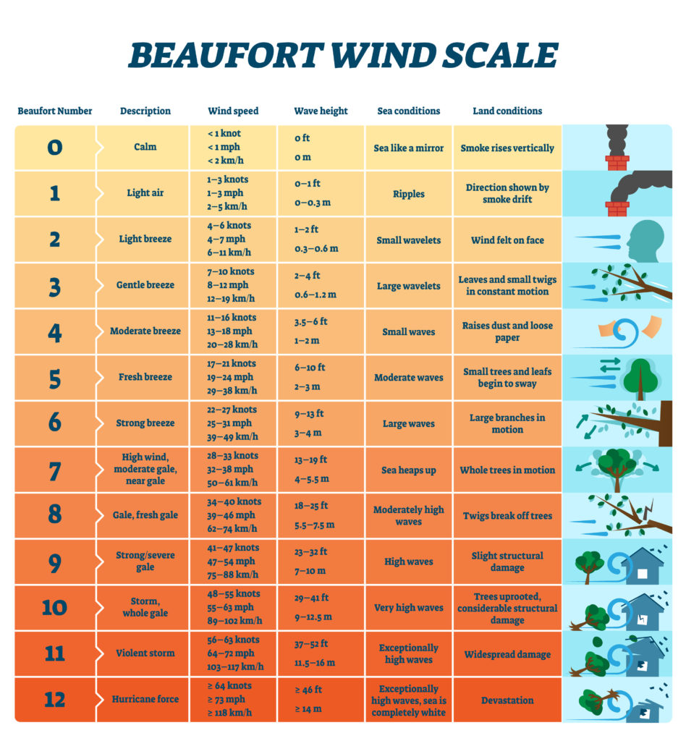

Assessment authorised by (Supervisor / Manager / Service Head)
Print: Warwick Neale |  |  |  | Signature: |  |  |  | Date: 19/04/2023
RISK RATING | RISK (R) | MANAGERIAL ACTION |  |  |  | RISK RESULT (Res) Low
1 & 2 | LOW | Monitor |  |  |  | A = Risk Level & Controls Acceptable
3 & 4 | MEDIUM | Attempt to improve controls so far as is reasonably practicable
6 & 9 | HIGH | Priority action to be taken to apply control measures |  |  |  | N = Risk Level & Controls Not Acceptable – Further Action Required
The Risk Assessment should be reviewed where circumstances change and/or at least annually. Significant changes will require a new risk assessment.
Assessment Review
Reviewed by: |  |  |  |  | Review date: |  | Existing risk assessment valid? (Y / N):
Has the activity changed? (Y / N):
How: |  |  | New controls:
Has new equipment or materials been introduced? (Y / N):
What: |  |  | New controls:

